Experiment – 4

**Aim : To design and verify truth tables of JK Flip Flop and Design Master – Slave JK Flip Flop using JK Flip Flop.**

**Tools :** Logisim 2.7.1(Open Source)

**Theory :**

1. **JK Flip Flop :**

A JK flip-flop is a sequential logic circuit that stores and manipulates binary information in digital systems. It is named after Jack Kilby, who designed it in the 1950s.

1. **Master – Slave JK Flip Flop :**

The master-slave flip flop is constructed by combining two JK flip flops. These flip flops are connected in a series configuration. In these two flip flops, the 1st flip flop work as "master", called the master flip flop, and the 2nd work as a "slave", called slave flip flop.

**Observation :**

* + **Logic Diagram of JK Flip Flop :**

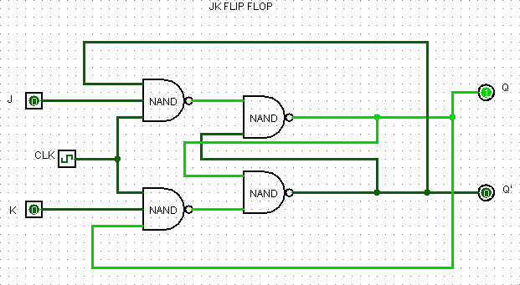

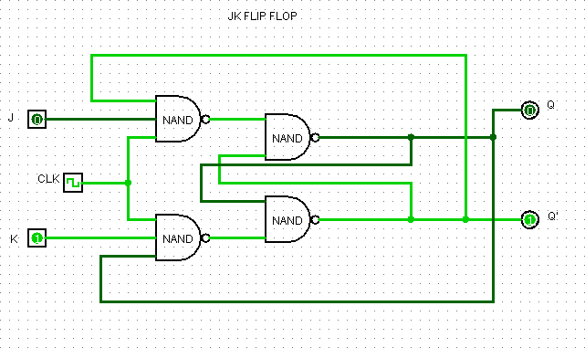

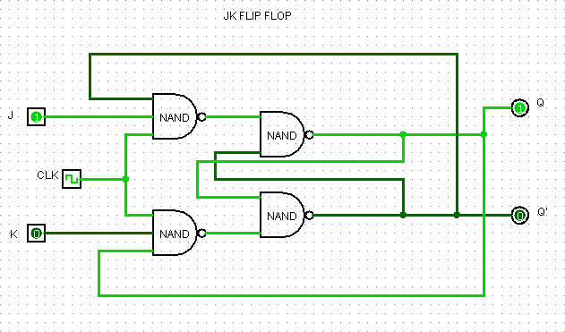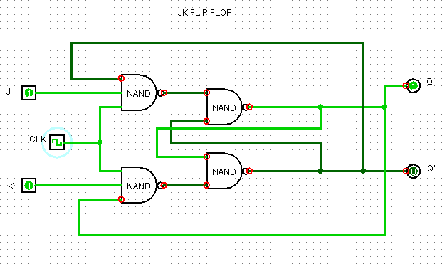

* + **Truth Table of JK Flip Flop :**

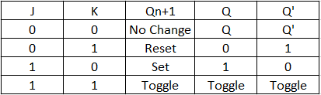

* + **Logic Diagram of Master – Slave JK Flip Flop :**

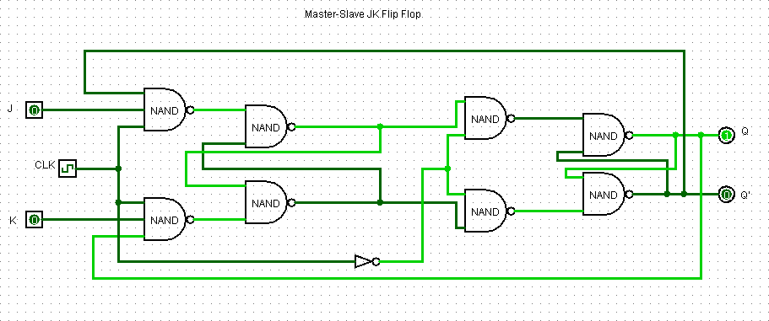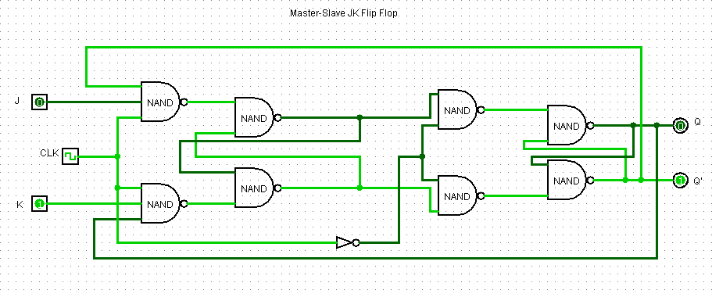

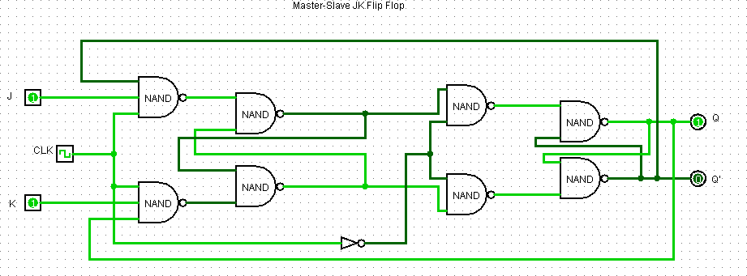

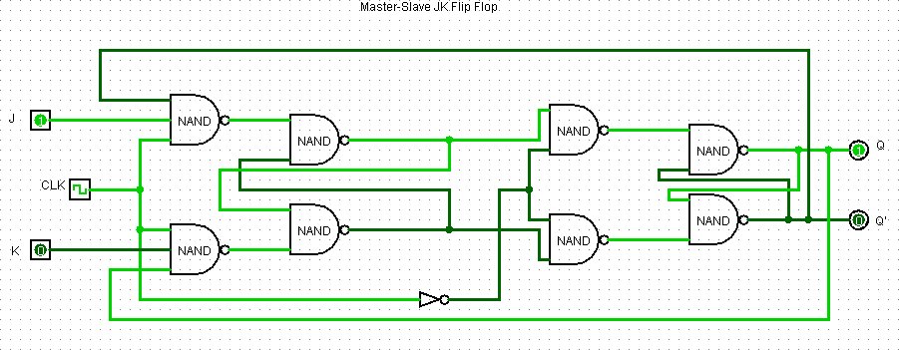

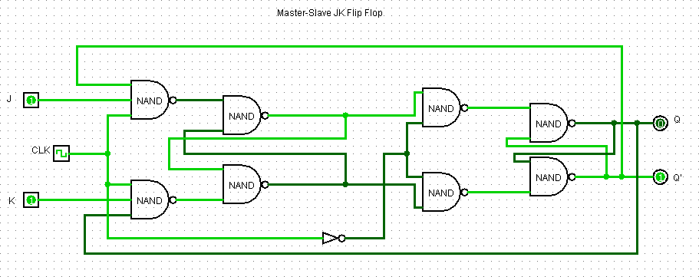

* + **Truth Table of JK Flip Flop :**



**Result:** Truth Table of JK Flip Flop and Master – Slave JK Flip Flop are verified via Logisim.

**Conclusion:** Circuit simulation and their TT verification can be achieved using open source “Logisim” software.